Currency Module Guide

Last Updated Date: November 22, 2024
Last Updated By: Marco Bertucci
Table of Contents
Foreign Exchange (FX) Conversion Function 3
How-To: Using Vena’s Foreign Exchange (FX) Conversion Function 3
Why use this feature? 3
Before you begin 3
How to Use the Foreign Exchange Conversion 4
Step 1: Select Model 4
Step 2: Add Currencies 4
Step 3: Specify Rate Types 4
Step 4: Build Template 5
Entering Conversion Rates 5
Deploy/Undeploy a function 6
Notes & limitations 6
Manually Deploying the Currency Module 7
Components 7
Month End Closing Rate and Average Rate 8
Config the Data Model 8
Setting up the FX Rate Input Template 12
Config the Calc Scripts 15
Setting up the FX Conversion Calc Consistency Report 23
Historical Rate Logic 25
Setting up the FX Historical Rate Flag Template 25
Setting up the CTA Calculator Template 27

Foreign Exchange (FX) Conversion Function

How-To: Using Vena’s Foreign Exchange (FX) Conversion Function
Use Vena’s Foreign Exchange (FX) Conversion Function to accommodate international transactions by setting up calculations that will convert currencies across your reports.
This article includes the steps on how to use Vena’s Foreign Exchange (FX) Conversion Function. For a list of frequently asked questions, see this reference article. For a demo, visit this link.

Why use this feature?
The Foreign Exchange (FX) Conversion Function may be suitable for you if you report, or plan to report, in multiple currencies and you have standard models without any existing FX Calcs.

Vena’s Foreign Exchange (FX) Conversion Function is a self-serve function that allows you to implement currency conversion calculations without the need for specialized formula knowledge. It is a function that works at the database level. You can easily set up automated calculations across your data model. Also, the Foreign Exchange (FX) Conversion Function will make your templates run faster since calculations are run in Vena’s engine. Follow the simple set up process using the step-by-step wizard and save time by setting up automatic calculations.
This feature is easy to set up and use and you can configure it to include more currencies as your company grows. Additionally, you can delete the function or undeploy it without impacting your data model. This feature sets everything up for you - no need to create templates or members.

Before you begin
To follow the instructions in this guide, you will need Modeler access. We highly recommend that you use this feature with a standard model. It is necessary that your model has the following dimensions: Account, Entity, Currency, Scenario, Year and Period. Additionally, you will need the following process variables: PlanningMethod, FiscalStartMonth, PlanScenario and LastClosedMonth. We recommend setting up the FX function after your data model set up is complete.

However, non-standard data models are supported if they meet certain criteria. For more information on using this feature with non-standard data models, visit this article.

How to Use the Foreign Exchange Conversion
- Navigate to the Modeler tab.
- Selection Functions from the sidebar.
- Select + Create to create a new function.
- Select Foreign Exchange Conversion as your type of function, followed by Next: Begin Setup → to launch the FX Function Set Up Wizard.

Step 1: Select Model
- Choose the data model for the function from the drop-down menu.
- Enter a name for the function or use the default suggested name. This must be a unique name.
- Select Next: Add Currencies → to continue to Step 2.

Step 2: Add Currencies
- Ensure all the Entity members that you plan to convert currencies for are listed in this table. All of the members from the Entity dimension will automatically appear in the table. You may edit these members by selecting the Edit icon next to Entity Members. Once in edit mode, check and uncheck the checkbox next to each specific member you want to include or exclude.
- Choose the appropriate functional currency you want to match each entity member to by using the drop-down menu.
- Choose the currency or currencies you will be reporting in from the drop-down menu.
- You must set one of your reporting currencies as your reference currency. By default, the first reporting currency will be set as the reference currency. You can assign another reporting currency as the reference currency by selecting the vertical ellipsis, followed by Set as Reference Currency.
- Select Next: Specify Rate Types → to continue to Step 3.
Note: The reference currency is usually your main reporting currency. It is the currency that will be used as a reference for calculating rates. For example, in a situation where you would have three functional currencies: US Dollar, Canadian Dollar and British Pound Sterling, and the US Dollar is set as your reference currency, you will only need to enter the conversion rates for US Dollar and Canadian Dollar, as well as US Dollar to British Pound Sterling. The rate between Canadian Dollar to British Pound Sterling will be calculated automatically based on the reference currency.

Step 3: Specify Rate Types
- Ensure all the Chart of Account members that you plan to convert currencies for are listed in this table. All of the bottom-level members of Balance Sheet and Net Income will automatically appear in the table. You may edit these members by selecting the Edit () icon next to Chart of Accounts Member. Once in edit mode, check and uncheck the checkbox next to each specific member you want to include or exclude.
- Choose the appropriate exchange rate type you want to match each chart of account member to by using the drop-down menu. The options are either Month End Rate or Average Rate.
- Select Next: Build Template → to continue to Step 4.

Step 4: Build Template
- Use the drop-down menu to choose how many years ahead you want to plan.
- Choose the process files library the input template will be stored in from the drop-down menu.
- Select Create Function. This creates the function and takes you to a summary of your function. You may choose to edit or make other changes to your function as you see fit. Now that your function is created, you must enter the conversion rates in the FX Formula - Rate Template document, follow the steps below to complete this.

Note: The function is not tied to the process, only the template is tied to the process. Even if the process is changed, the template will still work.

Warning: Editing a function will redeploy the whole function and create all the artefacts again. Avoid making any changes to your function unless it is absolutely necessary.

Entering Conversion Rates
In this stage, you will enter the exchange rates. It is recommended that you enter the exchange rates in the template before saving the values that need to be converted.

- Navigate to the Manager tab.
- Navigate to the Files Library of the process that you selected in Step 4.
- Select FX Formula - Rate Template to download the template.
- Open the template and enter the conversion rates.
- Select Save Data.
- The function will now use the conversion rates you entered for calculations.

Note: If you would like a Contributor to enter rates instead, this template can be assigned as an input task within a workflow.

Deploy/Undeploy a function
When a function is deployed, members are created, data is calculated and when any target scope is changed the FX value is calculated. When a function is undeployed, the calculated data is wiped out and the function does not run.
- Navigate to the Modeler tab.
- Select Functions from the sidebar.
- Select the function that you want to deploy/undeploy.
- Select Deploy or Undeploy.

Notes & limitations
- It is highly recommended that you use the FX Foreign Exchange Conversion Function on a standard model. Non-standard data models are supported if they meet certain criteria. For more information on using this feature with non-standard data models, visit this article.
- You can only have one FX Function per data model.
- If you exit the FX Function Wizard before completing all of the steps, it will be saved as a draft. The draft will be saved up until the last step that was fully completed.
- Each Entity can have one functional currency, but can have multiple reporting currencies. 1-to-1 and 1-to-many are supported, but many-to-many is not.
- For best results, we recommend that the rates be entered before the data.

Manually Deploying the Currency Module
As noted in the previous section, it is highly recommended to leverage the FX Conversion Function within Vena.

The below documentation was used for deploying the currency module prior to the development of the FX Function. In addition, the documentation below covers many-to-many currency conversions as well as Cumulative Translation Adjustments (CTA), which are not covered as part of the FX Conversion Function within Vena.

Components
Currency Templates:
FX Rates Input Template | This file will be used to enter the FX rates (Average rate for Income Statement, and Month-end Rate for Balance Sheet) from one local currency (eg. USD) to the reporting currencies. For instance USD to CAD, USD to GBP etc.
FX Historical Rate Flag | This file will allow the end-users to tag the Balance sheet accounts on which to use a Historical Rate instead of the Month-End rate.
CTA Calculator | Calculating Reporting currency and Cumulative Translation Adjustment (CTA) balances for accounts that need to be translated at histrocial FX rates as opposed to the month-end rates. The accounts commonly translated with this logic are Long-Term (Fixed) Assets, Long-Term Debt, Common Stock and Preferred Stock Balances, in addition to Retained Earnings.
FX Conversion Calc Consistency Report  (Data Validation) | This file will help you to validate the outputs of the FX Conversion Calc and FX Rates Calc (see calcs below).

Calc Scripts:
FX Conversion Calc | Convert the values in local currency to the reporting currency, based on the functional currency per entity and account type (Income Statement or Balance Sheet)
FX Rates Calc | Using USD as a reference point (can be set with any other reporting currency), calculate cross-exhange rates for currencies. For example, using the USD/CAD and USD/GBP rates, calculate CAD/GBP, for the purposes of multi-currency reporting.
CTA Aggregation Calc | Aggregate CTA adjustments calculated at the individual account level in the 'CTA Calculator' template to the CTA account under Shareholders' Equity.

Integrations:
FIN_Historical FX Maintenance | These channels help maintain attributes on Account members to drive the list of accounts where Historical Rates should be applied rather than Month End Rate in the FX Conversion Calc.

Month End Closing Rate and Average Rate

Config the Data Model

Configuring the Currency Dimension
Note: Members under the ‘All Reporting Currencies’ parent represent all the currencies in which a client reports their operations.

This dimension serves two purposes:

- Separate the functional currency of each entity (All Source Currencies parent) from the reporting currencies in which reports are presented (All Reporting Currencies parent).
- Store exchange rates under the All Reporting Currencies parent. Note your client’s data will exist under both the All Source Currencies parent as well as the All Reporting Currencies parent.

"What can I change in the hierarchy?"

It is important to note that all planning templates are mapped to the “Local” currency member, so the “Plan” scenario data is saved back to the functional currency of each entity and subsequently translated via calcs into the various reporting currencies that may be in use. The same logic applies to actuals (in the case we need to perform FX conversions on actuals), whereby the client’s GL data is loaded into the “Local” currency and subsequently translated into the various reporting currencies.

The “FX Conversion Calc” is mapped to pick up values from the “Local” currency and translate them into Reporting Currencies, as such, both the bottom level “Local” member and the “All Reporting Currencies” parent are referenced in the calc script.

More reporting currencies can be added if your client reports in a currency besides USD, CAD, or GBP; take care to add a corresponding member in the Measure dimension, as it is likely at least one entity uses this additional currency as a functional currency. You will also need to create a calculated member under the “All Entities by Source Currency” member to facilitate the “FX Conversion Calc Consistency Report”, this is detailed under Step 3 below.

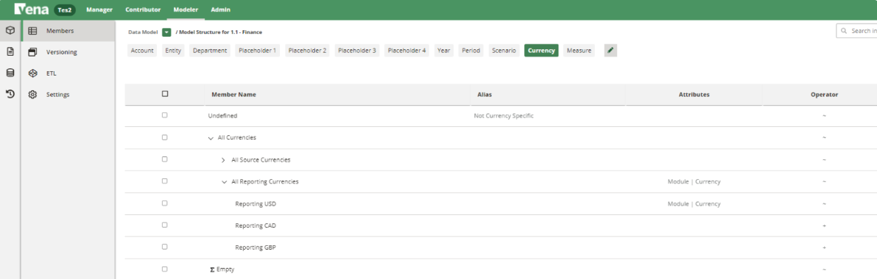

By default, the Finance cube comes with three pre-configured reporting currencies (USD, CAD, and GBP). In addition to the calcs documented here Step 3 (Currency) - Configuring the Calc Scripts [WIP], these currencies are used to expand the MDR in the “FX Rates Input Template” more detail on this template can be found here Step 2 (Currency) - Setting up the FX Rate Input Template [WIP].

The relationship between the Currency dimension and the Measure dimension is illustrated below
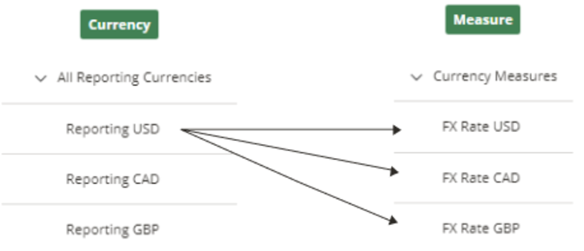

For each member under the “All Reporting Currencies” parent, we store a relevant exchange rate relative to a given currency in the Measure dimension. For example, in the screenshot below we see that the USD/CAD rate is 0.82 for the month of October.
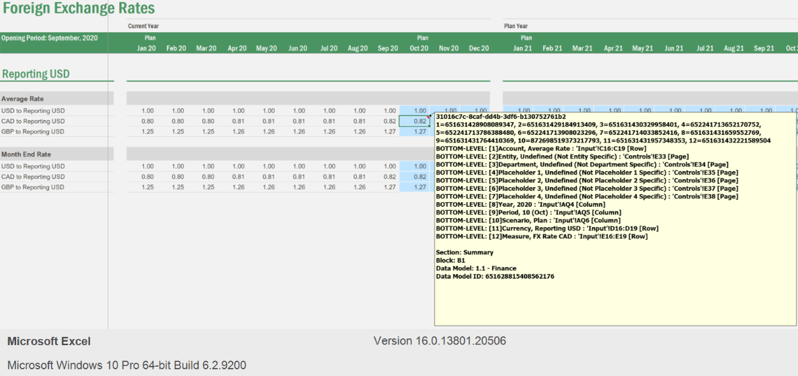

This can be interpreted as “one Canadian dollar buys 0.82 US dollars”. As you can see from the screenshot above, we provide inputs for the other two currency pairings as well.

2 - Configuring the Measure Dimension
NOTE: Members under the ‘Currency Measures’ parent represent all the currencies in which a client’s entities run their operations (Functional Currencies).

In relation to FX, this dimension only serves one purpose; to store FX rate data relative to the Currency dimension.

"What can I change in the hierarchy?"

This parent member is relatively flexible; it is not referenced directly in any templates/calcs/reports; members can be added here without significant downstream impact.

Be sure to tag an entity with the new Measure dimension member, and update the two calcs below to pick up the additional translation logic.

3 - Configuring the Entity Dimension
The relationships between functional currencies and Entities are controlled via attributes:
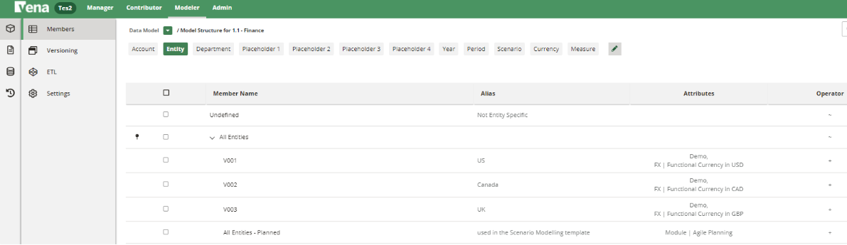

Since building the relationship between currencies and entities only needs to be performed once at the initiation of the project (and when subsequent entities are added), this is a manual step. The attribute nomenclature is “FX | Functional Currency in ***” where the last three letters relate to the functional currency of the entity.

The FX logic that has been built in Vena Paths relies on the assumption there is one functional currency per entity.

This attribute logic is used in 3 places:

- “FX Conversion Calc”
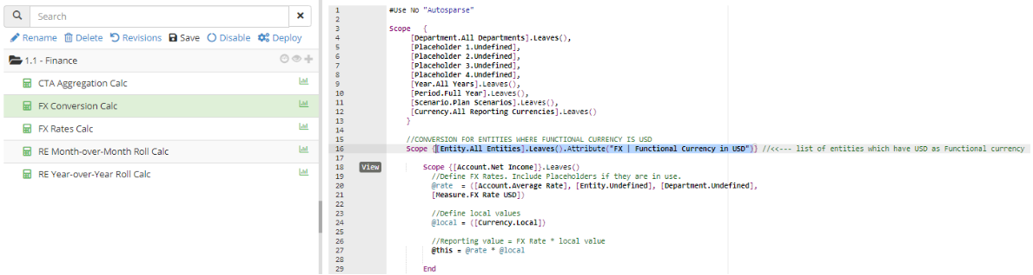

- In order to facilitate the “FX Conversion Calc Consistency Report”. Note this report is driven by calculated members in the Entity Dimension (descendants of “All Entities by Reporting Currency”), which use the following expression:
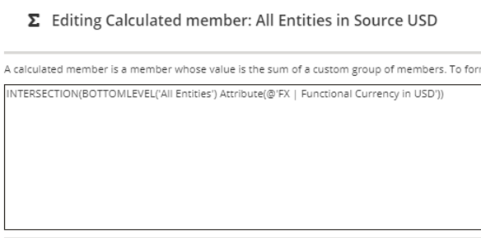

- The CTA calculator that is used for historical rate logic.

Setting up the FX Rate Input Template

Note: Best practice dictates that all entities are balanced in their respective “Local” currencies before any foreign exchange logic is built out. This can be accomplished by running the “Data Check Report”,

If you are out of balance, it is recommended you check the Retained Earnings logic, documentation on how to do this can be found here Checking Retained Earnings.

Functional and Technical overview
This template is meant to facilitate the input of exchange rates relative to a reporting currency (by default we use the USD). Even if you have multiple reporting currencies, there is only a need to input rates relative to one reporting currency.

Template Structure
This template contains 2 tabs:
- A Controls tab that contains all the template’s configuration:
  - Configuration Options
  - Sheet Protection
  - Show Calendar Month
  - Show Prior Year
  - FX Conversion on Actuals
- Mapping Contols
  - Reporting Currency
- Workbook Variables & Settings
  - Process variables for the Year, Period, and Scenario dimensions
  - Fiscal Year First Month set up (to drive Date Management
- Date Management (to drive the Date headers)
  - A Summary tab to facilitate input of exchange rates

Mapping Summary
Summary Tab
Section: Summary
Block: B1
- Page:
  - Entity: Undefined
  - Department: Undefined
  - Placeholder 1-4: Undefined
- Columns:
  - Year (FV)
  - Period (FV)
  - Scenario (FV)
- Rows:
  - Account: Average Rate, Month End Rate
  - Currency: Member Cell (Group1)
  - Measure: Bottomlevel(Currency Measures)

Setting up the FX Rate Input Template
This template is based on the assumption that the client has USD as one of their reporting currencies; if this is not the case, the below cell needs to be updated:
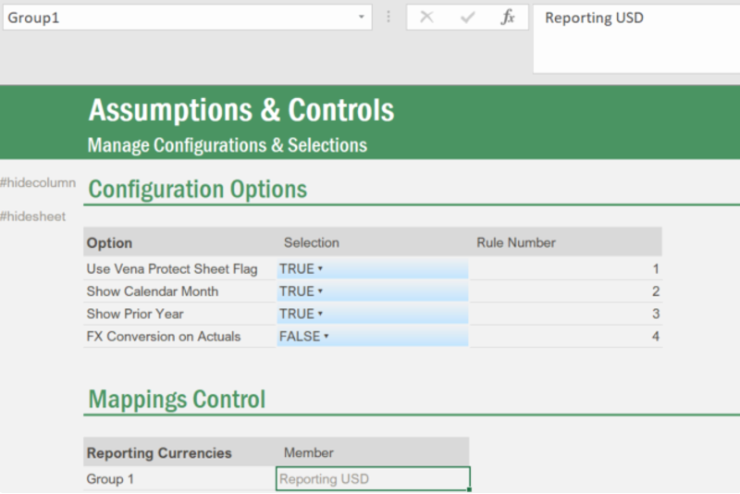

Note you will also need to update the “FX Rates Calc” as well as the “FX Conversion Calc”, logic on how to do this can be found here Step 3 (Currency) - Configuring the Calc Scripts [WIP].

By default, there is no FX calculation performed on the “Actual” scenario, if your implementation requires such logic, you will need to set the toggle in the red box to TRUE.
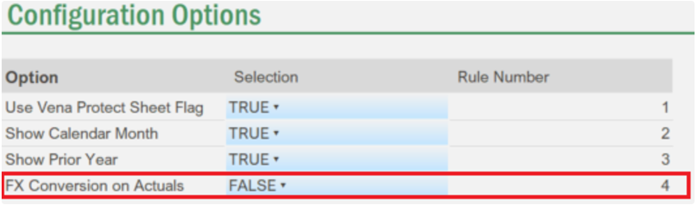

You will also need to set the cells below to be input cells:
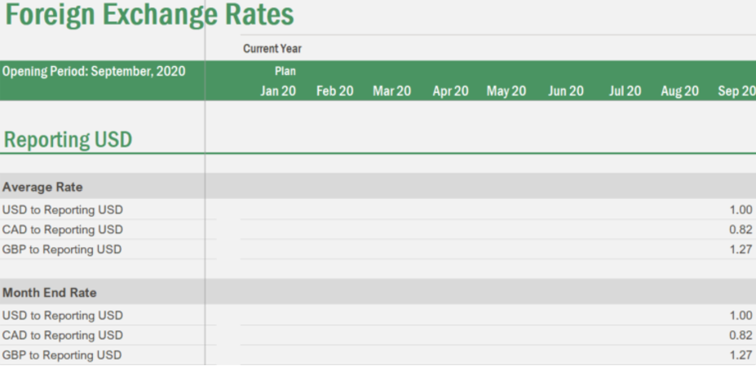

This can be accomplished by using the cell styles that are pre-built in the Path templates:
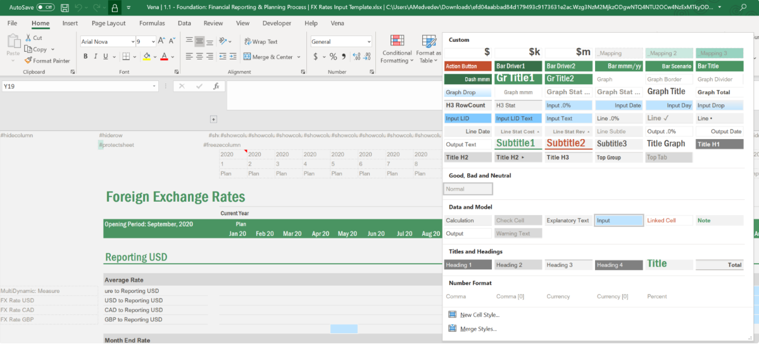

Config the Calc Scripts
NOTE: The calcs below are presented in order of execution (if exchange rate changes). If the exchange rates stay constant and the GL data changes, the second calc (FX Conversion Calc) will execute while the first calc will not.

Also note the first calc (FX Rates Calc) is only necessary if you have multiple reporting currencies.

The logic for a change in exchange rates is best illustrated with a data flow; in this situation we are entering the CAD exchange rate for the USD reporting currency (“Reporting USD” member under the Currency dimension, and “FX Rate CAD“ under the Measure dimension).

We are subsequently using this rate to report in CAD for an entity whose functional currency is the USD. It is the conversion from the USD/CAD rate to the CAD/USD rate that the “FX Rates Calc” is used for.
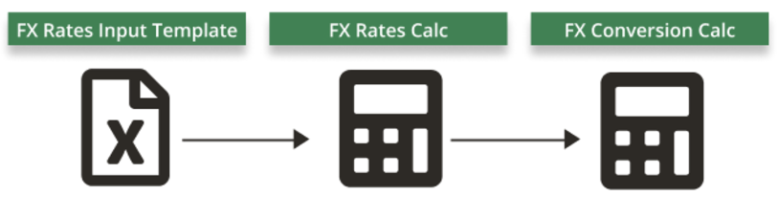

FX Triangulation
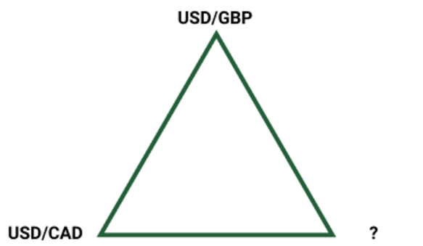
Before diving into the various scopes of this calc, it is useful to understand the concept of FX triangulation, in the example above we have two rates that are input by the user: USD/CAD and USD/GBP, these two rates can be used to determine:

- GBP/CAD
- CAD/GBP

Additionally, we can determine both the CAD/USD and the GBP/USD rates by taking the reciprocal of the USD/CAD and USD/GBP rates, respectively. This kind of logic becomes useful when doing multi-currency reporting; this is in contrast to manually keying in the 4 rates mentioned above, which has the potential to cause issues due to input error.

FX Rates Calc
Note: By default, this calc is set to run on planning scenarios only.

In the files library, go to 1.1 - Foundation: Financial Reporting & Planning Process > 2 - Currency Module > 2.1 - FX Conversion Template, here you will find the two calcs mentioned in this article.

Building off the triangulation logic above, the “FX Rates Calc” is used to calculate the rates between all currencies, using one set of rates as a starting point (by default, we use USD).

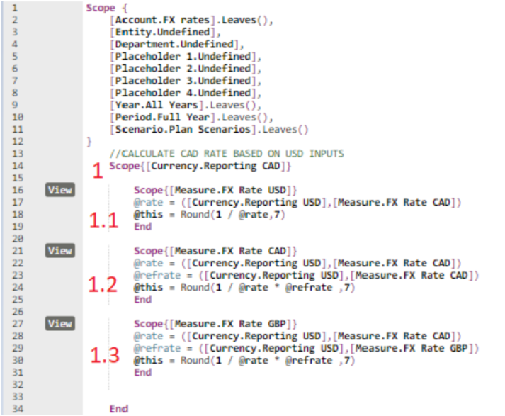

In the screenshot above, subscope 1 is used to direct the calc to write to the “Reporting CAD” member in the Currency dimension, subscope 1.1 is used to direct the calc to write to the “FX Rate USD” member in the Measure dimension. This saves back the CAD/USD rate mentioned in the triangulation logic above.

To illustrate how to add an additional currency to the calc received on migration, we will work through adding the EUR currency to the calc script (assuming the Model has already been modified to accommodate for this). Additionally, we will assume that the USD/EUR rate has been entered into the “FX Rate Input Template”.

Adding new currency to existing reporting currency scopes
To set the CAD/EUR rate, we would need to add subscope 1.4 to the logic above, this would look as such:

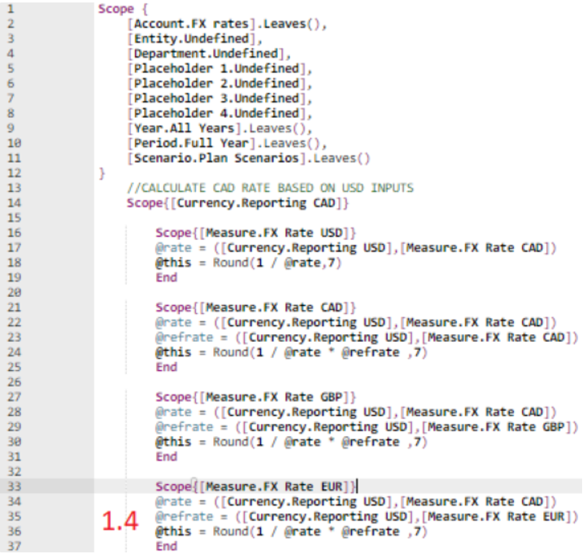

It’s a matter of taking the subscope that writes to the “FX Rate GBP” Measure (subscope 1.3) and changing the GBP currency to the EUR.

This needs to be done for each reporting currency subscope.

Adding new subscope for new reporting currency
To set the EUR/USD, EUR/CAD, and EUR/GBP rates, a new subscope needs to be created. This would look as such:

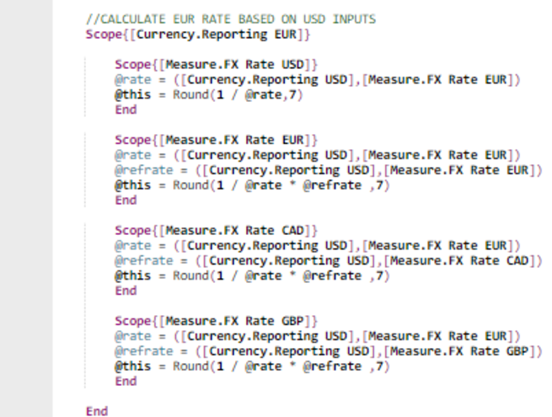

Starting with an existing currency subscope and copying it down to re-arrange the currency references is best practice in for this.

FX Conversion Calc
Note: By default, this calc is set to run on planning scenarios only.

This calc takes the FX rates calculated in the “FX Rates Calc“ and values saved under the “Local” currency to perform the FX conversion into various reporting currencies.

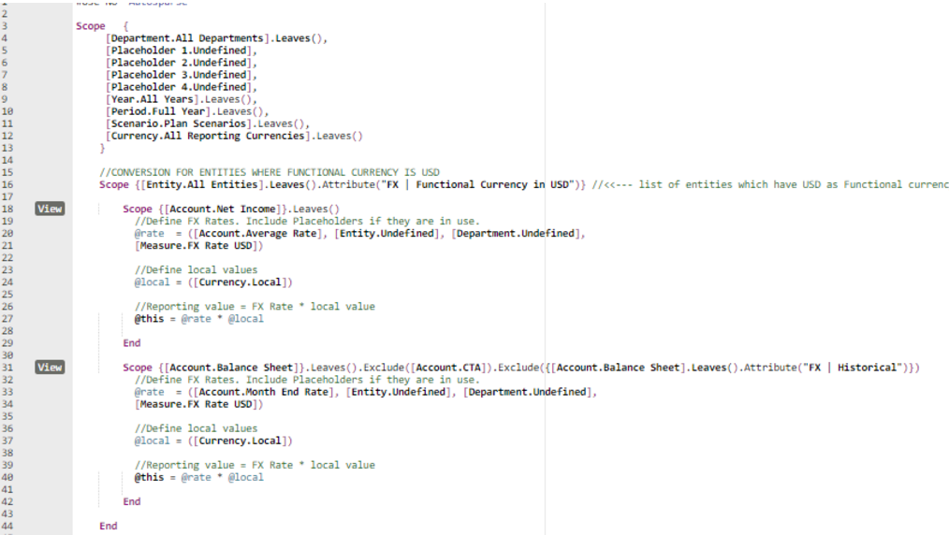

The only time the above calc needs to be modified in a material way is when entities with additional functional currencies are added.

There are two subscope layers in this calc:

- The first layer narrows the destination intersections to entities whose reporting currencies are specified via the “FX | Functional Currency in XXX” attribute (in the above screenshot, that currency is USD).
- The second subscope layer differentiates between Income Statement and Balance Sheet accounts; if these members get altered in the model, their equivalents need to be put into this calc.

Note: the Balance Sheet subscope filters out the “CTA” member as well as the “FX | Historical” attribute under the Account dimension, this is done to facilitate optional historical FX logic, more documentation on which can be found here Historical Rate Logic

Frequently asked questions on Foreign Exchange
I am in a ‘many : 1' or 'many : many’ case, how can I adapt?

The first “many” word in the expressions “many to 1” or “many to many” means that a single entity plans in multiple currencies which is very rare. Usually an entity plans in 1 currency only. If you decide to implement this it will require some changes from the Foundation package solution and is considered “Advanced currency”. Before implementing this make sure you understood the requirements properly.

The last “many” word means that the company reports in multiple currency at a consolidated level which is more frequent and very easy to accommodate using the foundation package.

The main change when moving from a 1 : x case to a many : x case is the dimension defining the different Source currencies:

- in the 1 : x case, each entity should have only one source currency (Local). They are defined within the Entity dimension.
- in the many : x case, each entity can have data across several source currencies, so we need to leverage 2 dimensions. The Source currencies will be set within the Currency dimension (1 dimension), or the Source Currency Dimension (2 dimensions)

Areas |  | 1 : 1 or 1 : many | many : 1 or many : many  (1 dimension) | many : 1 or many : many  (1 dimension) * | many : 1 or many : many  (2 dimensions)
Data Model | Entity | - All Entities by Source Currency  - All Entities by Source USD  - All Entities by Source CAD  - All Entities by Source GBP  + attributes FX | All Entities by Source XXX |  | - All Entities  - Entity A  - Entity A - USD  - Entity A - CAD  - Entity A - GBP  + attributes FX | All Entities by Source XXX
Data Model | Measure | - All FX Rates  - FX Rate USD  - FX Rate CAD  - FX Rate GBP | - All FX Rates  - FX Rate USD  - FX Rate CAD  - FX Rate GBP | - All FX Rates  - FX Rate USD  - FX Rate CAD  - FX Rate GBP | FX Rate  (one member)
Data Model | Currency (Reporting Currency) | - All Source Currencies  - Local  - All Reporting Currencies  - Reporting USD  - Reporting YYY | - All Source Currencies  - USD  - CAD  - GBP  - All Reporting Currencies  - Reporting USD  - Reporting YYY | - All Source Currencies  - Local  - All Reporting Currencies  - Reporting USD  - Reporting YYY | - All Source Currencies  - Local  - All Reporting Currencies  - Reporting USD  - Reporting YYY
Data Model | Source Currency | not in use | not in use | not in use | - All Source Currencies  - USD  - CAD  - GBP
Calc Scripts |  | Same as delivered in the FX Module | FX Calc - Multi Local Currency Approach
FX Rates Input Template |  | Step 2 (FX) - Setting up the FX Rates Input Template | No Change | No Change | You need to change the mapping in rows to split the original measure member (FX Rate CAD) in a combination of measure (FX Rate) - Source currency (CAD)
FX Check Report |  | Step 3 (FX) - Setting up the FX Check Report | Check the changes within hidden tab FX Results (Many-1 dim) |  | Check the changes within hidden tab FX Results (Many-2 dim)
Considerations |  |  | Easier to map a template and report  You lose granularity on your planned and actual data for reporting case (but you can still see the details via Drill Calcs) |  | You keep granularity on your source data  The calc is extremely easy to set up (no need to create separate scope for each source currency)  Time consuming to remap templates and reports from the Foundation package as you have to define both dimensions

Setting up the FX Conversion Calc Consistency Report

Functional and Technical overview
The FX Check Report allows you to validate the outputs from the calc scripts against the calc logic in Excel. It is intended to highlight the discrepancies within a single Reporting Currency.

Template Structure
This template contains 2 tabs:

- A Controls tab that contains all the template’s configuration:
  - Configuration Options
    - Sheet Protection
    - Show Calendar Month
    - Show Prior Year
    - FX Conversion on Actuals
  - Mapping Contols
    - Net Income mapping
    - Assets mapping
    - Liabilities mapping
    - Stockholders Equity mapping
  - Workbook Variables & Settings
    - Process variables for the Year, Period, and Scenario dimensions
    - Fiscal Year First Month set up (to drive Date Management
  - Date Management (to drive the Date headers)

Setting up the FX Conversion Calc Consistency Report
NOTE: The ultimate objective of this template is to ensure the check below reads “GOOD”.

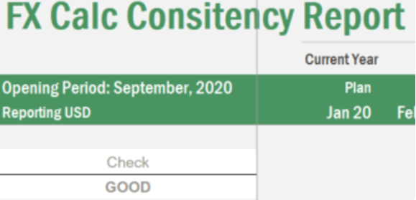

The first step in configuring this template should be to ensure the Mappings Control section has the correct accounts listed for Net Income, Assets, Liabilities, and Stockholders Equity, as per below (the second column needs to be aligned to member names in the cube).

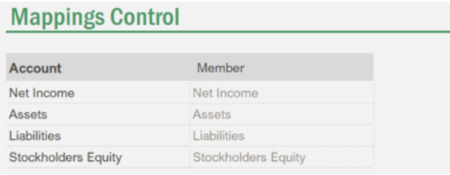

The summary tab performs 4 functions:

- Retrieves local currency values for the accounts specified above:

- Retrieves values calculated in the cube (for all entities, in the reporting currency chosen on template open):

- Using the FX rate retrieve and the local currency values for various entities retrieved in step 2, replicates the calc logic:

- Compares the two sets of values.

NOTE: If you have reporting currencies other than CAD, USD, and GBP you will need to manually add these in to the Summary B1 block as new rows.

By default, the template does not perform a check on Actuals; if this is something your client requires, the “FX Conversion on Actuals” toggle in the Controls tab needs to be set to TRUE.

If you are using historical rate logic, it is normal that you see numbers appear in the first section, as such:

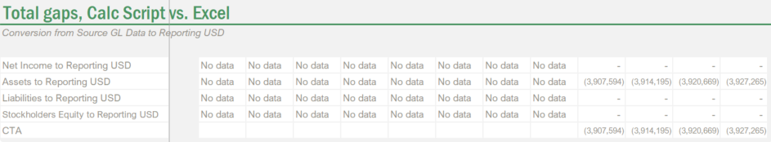

This is because some accounts are valued using historical rates. If the built-in check reads “GOOD” you don’t need to worry about these.

Historical Rate Logic
NOTE: Under IFRS and US GAAP all monetary balance sheet items (short term assets and liabilities) are translated at month end rates due to their liquid natures. Long-term assets and liabilities are translated at historical rates, what this means in practice is that monthly changes in these accounts (in local currency) are translated at monthly FX rates and accumulated to effectively roll forward the balances in reporting currencies. More documentation on this can be found here Historical FX.

This logic applies exclusively to balance sheet accounts.

Depending on how sophisticated you client’s existing Foreign exchange logic is, it is quite possible that all their balance sheet accounts are translated at the month end rates and this logic is not required. There are two actions that can help you diagnose if historical FX logic is required:

- Ask your client as part of discovery;
- Take one entity and determine the rate at which balance sheet items were translated for a given period by dividing values in the reporting currency by the values in local currency. For any accounts where the rate is not equal to the month end rate, historical logic is required.

Setting up the FX Historical Rate Flag Template

Functional and Technical overview
The purpose of this template is to facilitate flagging accounts for which historical rate logic is required, this is accomplished by:

- Saving a ‘FX | Historical’ value into account-specific intersections,
- Using the above intersections to attach a ‘FX | Historical’ attribute to those accounts through integration channels.

Template Structure
This template contains 2 tabs:

- A Controls tab that contains all the template’s configuration:
  - Configuration Options
    - Sheet Protection
- An Input tab to facilitate saving back intersections with the ‘FX | Historical’ value.

Setting up the ETL Template
- Go to Modeler > select the cube (e.g. 1.1 - Finance)
- Go to ETL > Templates > Add Template
- Give it a Name (e.g. 4 - Historical FX Maintenance) and attach the two following channels
  - FIN_HistoricalFXMaintenance_Step 1_DetachAttributes
  - FIN_HistoricalFXMaintenance_Step 2_AttachAttributes
- Take note of the ETL Template ID for the next step (Setting up the ETL Trigger)

Depending on the intersection created above, the channel FIN_HistoricalFXMaintenance_Step 2_AttachAttributes will create the relevant attribute through the channel below:
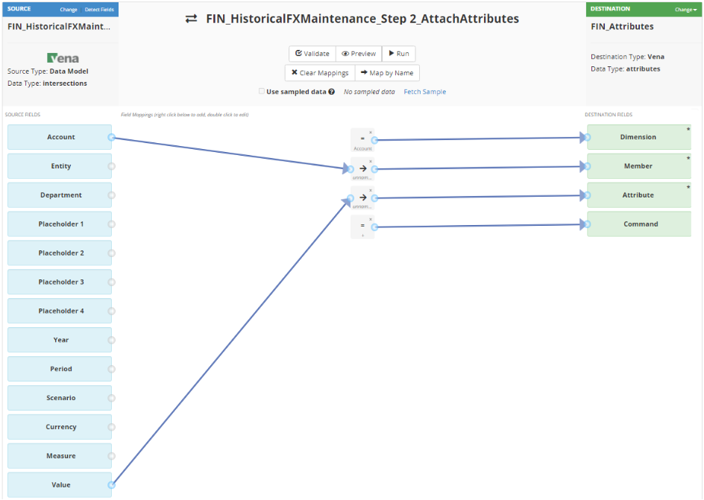

Setting up the ETL Trigger
- You can review the steps in the following article: ETL Trigger Set-up
- Select/Delete a couple of accounts to flag on the template and hit save data.
- Check that an ETL job fired and executed successfully (Modeler > History) and check the leaf accounts on the modeler to make sure the attribute got detached/attached successfully.

Setting up the CTA Calculator Template

Functional and Technical overview
The purpose of this template is two-fold:

- Calculate the reporting currency balances for all accounts which are tagged with the ‘FX | Historical’ flag,
- Calculate the CTA gain/loss attributable to these accounts.

Template Structure
This template contains 7 tabs:

- A Controls tab that contains all the template’s configuration:
  - Configuration Options
    - Sheet Protection
    - FX Conversion on Actuals
  - Mapping Contols
    - Balance Sheet Department
  - Workbook Variables & Settings
    - Process variables for the Year, Period, and Scenario dimensions
    - Toggle between Regular Planning / Rolling Forecast
    - Fiscal Year First Month set up (to drive Date Management)
  - Selection
    - Choosebox on the Account dimension limited to accounts tagged with the ‘FX | Historical’ attribute, as well as the Entity and Currency Dimension (note the currency relates to the currency you are translating into, not necessarily the functional currency of the entity selected)
  - Driver attributes to control the entities that get retrieved in the List tab
  - Date Management (to drive the Date headers)
- A Local Currency (incl. Actuals) tab that is meant to be used if you are performing FX translations on Actuals. Note the user will need to define the first period for which data is available for both the local and the given reporting currency (more below).
- A Local Currency (Forecast) tab that is meant to be used if you are performing FX translations on planning scenarios only. Note the first period retrieved is the aligned to pvYear and pvPeriod.
- A Retrieve FX tab that retrieves exchange rates.
- A Calculate Reporting Currency tab that calculates and saves values for the given Account, Entity, and Currency combination, effectively replacing the “FX Conversion Calc”.
- A Calculate CTA tab that calculates and saves the CTA adjustment values (“CTA” Measure) for the given Account, Entity, and Currency combination.
- A List tab that retrieves years (to be used on the “Local Currency (incl. Actuals)” tab if needed.

Mapping Summary
Tabs | Section Name | Blocks
Local Currency (incl. Actuals) | SaveStartPeriod  - Page  Entity: Undefined  Department: Undefined  Placeholder 1-4: Undefined  Year: Undefined  Period: Undefined  Scenario: Undefined  Currency: Undefined | B1  - Columns: Measure (Start Year, Start Period)  - Rows: Account (*FV)
Local Currency (incl. Actuals) | RetrieveLocal  - Page:  Account: (*FV)  Department: (*FV)  Placeholder 1-4: Undefined  Currency: Local  Measure: Value | B1  - Columns: Entity (*FV)  - Rows: Year (*FV), Period (*FV), Scenario (*FV)
Local Currency (Forecast) | RetrieveLocal  - Page:  Account: (*FV)  Department: (*FV)  Placeholder 1-4: Undefined  Currency: Local  Measure: Value | B2  - Columns: Entity (*FV)  - Rows: Year (*FV), Period (*FV), Scenario (*FV)
Retrieve FX | RetrieveFX  - Page:  Entity: Undefined  Department: Undefined  Placeholder 1-4: Undefined  Currency: (*FV) | B2  - Columns: Currency (*FV)  - Rows: Account (Average Rate, Month End Rate), Year (*FV), Period (*FV), Scenario (*FV)
Calculate Reporting Currency | SaveReporting  - Page:  Account: (*FV)  Department: (*FV)  Placeholder 1-4: Undefined  Currency: (*FV)  Measure: Value | B1  - Columns: Entity (*FV)  - Rows: Year (*FV), Period (*FV), Scenario (*FV)
Calculate CTA | SaveCTA  - Page:  Account: (*FV)  Department: (*FV)  Placeholder 1-4: Undefined  Currency: (*FV)  Measure: CTA | B1  - Columns: Entity (*FV)  - Rows: Year (*FV), Period (*FV), Scenario (*FV)
List | List | B1  - Rows (dynamic): Year, Entity (by reporting currency)  This will generate a Incomplete Block Warning message. You can dismiss this message.

Setting up the CTA Calculator Template
The “FX Conversion on Actuals” flag will determine whether the “Local Currency (incl. Actuals)” or the “Local Currency (Forecast)“ tab is used to calculate the CTA adjustment:

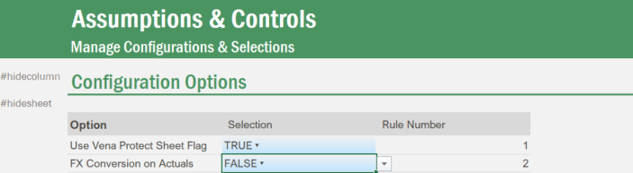

If there is a requirement to calculate actuals with historical rates, the customer will need to provide a starting point from which balances will be rolled forward. This requires the two steps mentioned below.

Setting up the opening year and period:

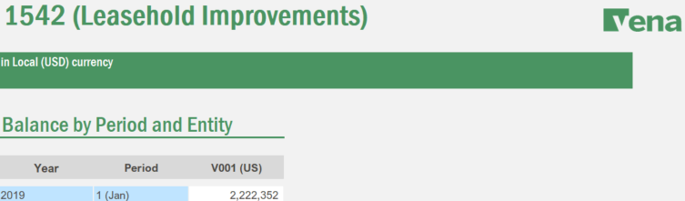

The year and period that are entered into these cells are saved back to account-specific members to facilitate the use case where different accounts have different starting dates.

Entering reporting currency values:

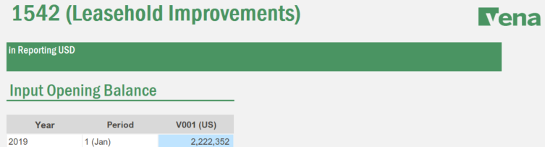

This cell above will be used as a starting point from which all future balances will be calculated; it needs to be entered in the reporting currency which you selected in the choosebox.

Due to the inter-dependencies the blocks in this template have, a customized refresh has been pre-set in order to avoid the need for having to refresh the template multiple times:

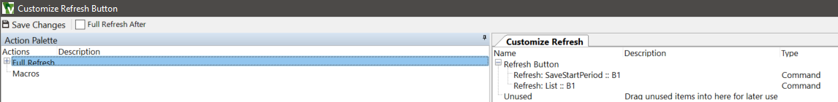

This has been pre-configured using the Customized Refresh feature under Actions:

